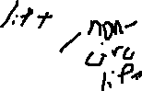

Eigenvalue on a matrix

Match aeroelast frequency and aerody frequency of vibr

